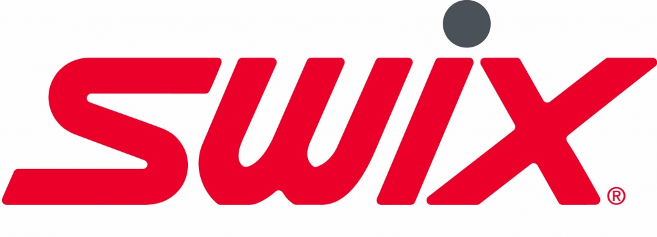

Wax Recommendation for Yellowstone Rendezvous Race
Forecast:
Friday, March 6, 2020 (pm): Partly Cloudy with a low around 22F. Wind out of the South 6-8mph
Saturday, March 7, 2020 (am): A 40% chance of rain and snow after 11:00am. Mostly cloudy with a high near 44F. Winds out of the southwest at 6-11mph, gusting to 28mph.
Glide Wax: With the warming trend forecast for the week and the continual transformation of the snowpack we are forecasting the snow to be spring like and will respond to a base layer of CH, LF, or HF 6. This layer will help with the overnight freezing snowpack and durability. We would then suggest a layer of CH, LF or HF 7 and 8 mixed for your second layer. Add FC 8 for the ultimate fast layer.
Kick Wax: This will be hard to estimate, but as the snowpack warms, we would expect to be on a Silver Universal Klister, on a base binder, covered by VR 45. This suggestion will be very dependent on the weather the day of the race.
Structure: We would suggest an all around, medium structure and a warm structure on your second pair of skies for the 50 Skate race.

